

Too often do gardeners do just a bit more than they intended to do when it comes to weeding. They frequently damage the roots of nearby healthy plants at the same time, which is just as productive as, even as painful as, pulling out a good tooth at the same time as a bad tooth. And sometimes these gardeners may even hurt themselves while kneeling or bending their backs to yank out weeds … which can be just as painful as, well, a sore knee or a sore back. But it doesn’t have to be this damaging or painful, and not to any person or any plant. Just use the Two Tine Weed Fork.

The Two Tine Weed Fork is just as its name implies – two tines projecting from an extended handle, and for use in removing weeds from lawns and gardens. The tines are made of a durable metal material, each with a slight curve, and each is mounted for vertical extension from a horizontal base bar. Also extending vertically from this base bar, and from the opposite side of the tines, is a mounting neck. Into this neck can the handle of the Two Tine Weed Fork be attached. This wooden handle is approximately four feet in length.

Users can simply insert the tines of the Two Tine Weed Fork into the ground near or upon a weed, and no matter how close to a plant that weed may be. Then, by rocking or gyrating the handle, the weed can be removed from the ground, roots and all. No need to bend over or kneel, no need to risk loosening the roots of the nearby plants by inserting a larger-headed tool, no need to use expensive and dangerous chemicals – just use the Two Tine Weed Fork to get the job done quickly and easily.

Americans by far love to tend their gardens, and spend quite a bit of money every year specifically for tools to help them do their gardening. The Two Tine Weed Fork, which your company is invited to include in its product line, can appeal to this large and high-spending consumer market.

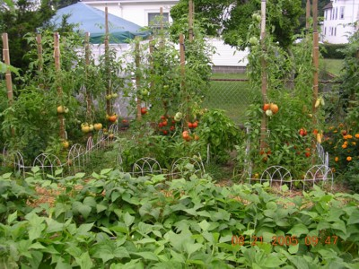

Features & Benefits

Of
The Two Tine Weed Fork

Features

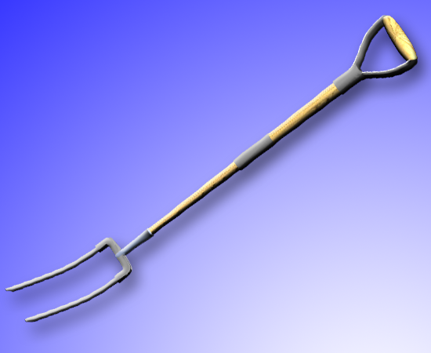
- Base head of stainless steel rod

- With two (2) tines attached to base

- rod of approximately 4” x 1” size

- Each tine measuring 10 ½” x ½” and

- extending at 30º angle of curvature

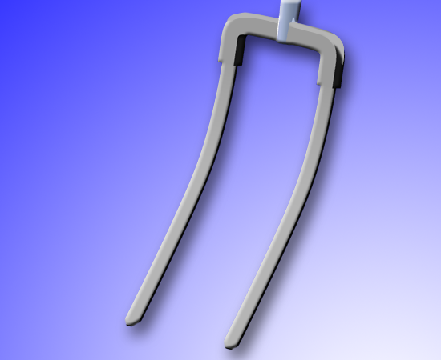
- Neck of approximately 3” x 1” size extending from base rod at opposite side of tines

- Handle of 4’ x 1” size and made of treated wood extending from neck

- Screw(s) for attachment of handle to neck
Benefits

- Removes weeds from lawns and gardens

- Can be applied to small area

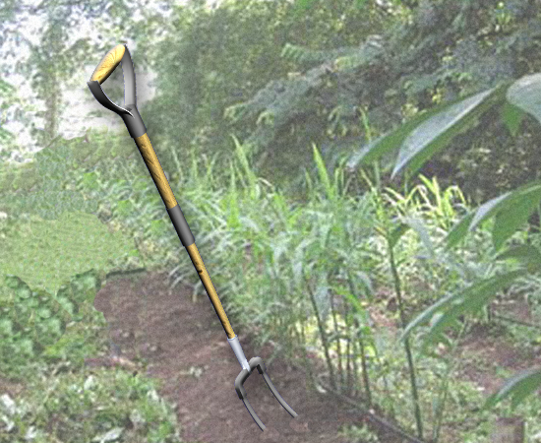
- Doesn’t damage area around weeds

- Of size to allow application upon small area without unnecessarily piercing surrounding area

- Projects in depth needed to remove weeds by roots

- Performs better than four-tined hoes and pitchforks

- Removes weeds easier than by hand

- Removes weeds with less physical stress than by hand

- Removes weeds better than by hand

- Allows weeds to be removed while standing instead of while kneeling

- Removes weeds safer than by chemicals

- Removes weeds faster than chemicals

- Removes weeds without damaging surrounding area, unlike chemicals
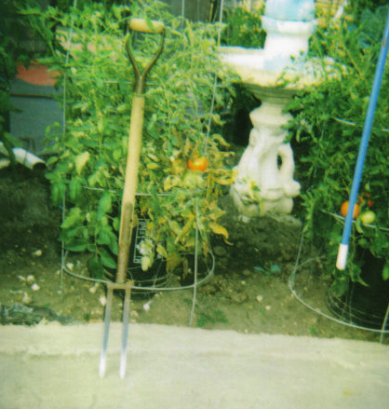
- Removes weeds with more success in single application than chemicals

- Removes weeds much less expensively than chemicals

- Can appeal to a very large consumer group

- Can meet the particular wants and desires of this consumer group

- Can join a very successful product line

- Can easily and quickly achieve profitability

Pertinent Manufacturing Industries

Of
The Two Tine Weed Fork

SIC | Industry | Companies | Annual Sales  (in $ Billions)
3423 | Hand & Edge Tools | 1,122 | $5.487

The Two Tine Weed Fork can be presented to particular businesses in this industry, which includes companies that make outdoor and gardening tools such as shovels, rakes, pitchforks and other similar products.

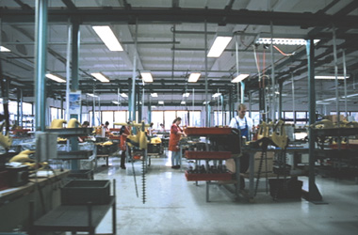

The following chart shows the recent sales history of the Hand & Edge Tools manufacturing industry:

Source: U.S. Bureau of the Census

First year/last year comparison shows a 3.36 percent decline in gross dollar sales. This drop doesn’t necessarily mean loss in profit, however. For example, when the cost of production goes down, then the selling price goes down, too. For example, the metal materials used by these companies have decreased steadily in costs through 2004. Today, this industry maintains the same profitability (in net dollars) as it did in 2000.

Wholesale Industry

Of
The Two Tine Weed Fork

SIC | Industry | Companies | Annual Sales
5072 | Hardware | 8,473 | $47.005 billion
5083 | Farm & Garden Equipment | 12,320 | $50.015 billion

Hardware wholesale companies are chief distributors of household tools and lawn tools, and can also include the Two Tine Weed Fork in their wares.

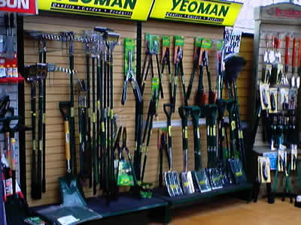

The following chart shows the recent sales history of Hardware merchant wholesale companies:

Source: U.S. Bureau of the Census

Annual sales of Hardware merchant wholesalers grew a very impressive 40.05 percent in the last five years.

The Two Tine Fork can be distributed with other gardening utensils and farming tools, as well.
The following chart shows the recent sales history of the Farm & Garden Equipment merchant wholesale industry:

Source: U.S. Bureau of the Census
Annual sales of this industry grew 22.41 percent in the last five years.

Retail Industry

Of
The Two Tine Weed Fork

SIC | Industry | Companies | Annual Sales
5251 | Hardware Stores | 23,265 | $20.791 billion
5261 | Nurseries and  Lawn & Garden Supplies Stores | 23,969 | $15.889 billion

The Two Tine Weed Fork can certainly be included in the product lines of Hardware Stores, which are actually responsible for 45 percent of the sales of all lawn and garden products.



The following chart shows the recent sales history of Hardware Stores:

Source: U.S. Bureau of the Census

Annual sales of Hardware Stores grew 28.5 percent in this five-year period.

Nurseries and Lawn & Garden Supplies dealers are primary retailers of gardening tools, and the Two Tine Weed Fork can certainly be included in this retail industry, as well.

The following chart shows the recent sales history of Nurseries and Lawn & Garden Supplies stores:
Source: U.S. Bureau of the Census

Annual sales of this very pertinent retail industry have soared in recent years, and increased 42.49 percent since 2002.

Marketing Potential

Of
The Two Tine Weed Fork

The Two Tine Weed Fork is capable of quick and immediate return
by appealing to a large and active consumer group.
  - The field of lawn and garden products is immense in size and immense in sales. After all, 79 percent of all U.S. households participate in one or more do-it-yourself gardening activities every year, and 56 percent of all Americans perform all of their lawn and garden tasks independently.

  - And this large group of Americans who perform these tasks spend large amounts of money for relevant tools, too. In fact, Americans spent $10.3 billion on this product line last year. That’s not lawn mowers or tractors, not watering equipment or garden hoses, not power equipment and not plants or fertilizers, either. That’s on the basic simple items similar to the Two Tine Weed Fork, like shovels, spades, hoes and rakes. And this amount has been growing by approximately $200,000 every year.

  - This comes to $91 on average for every U.S. home specifically for items like the Two Tine Weed Fork. And this market is still growing, too. As a result, it’s safe to say that this new product could easily reach high sales within an established and growing market, and very quickly, too.

  - If your company could only reach one tiny percent of these consumers, that still amounts to sales of about 900,000 units of the Two Tine Weed Fork. And even at its lowest estimated retail price, this still amounts to almost $15 million in sales.

The Two Tine Weed Fork can fill an established need
of this large and active consumer group.

  - Most folks wish their gardens were larger, and not just because they want to grow more plants. They just want a lot more room to do their gardening tasks, and because their plants could be easily damaged, and during many typical duties. Even worse, these gardeners could damage themselves, too.

  - Sure, they know how important it is to remove unwanted weeds, and not just for the appearance of their gardens. They just don’t want to spend so much time on their hands and knees to do so. That would be true for everyone, but especially today’s American gardeners, who have a median age of over 50 years.

  - And if they use regular-sized tools that allow them to stand up to remove the weeds, then they pose a risk to the plants, because the size of those shovel heads and space of the four-tined pitchforks can result in their accidentally digging up the roots of the plants they try to save. And if they use chemical products, then they pose a risk to both themselves and their plants at the same time.

  - And that’s why these very active gardening consumers will have so much interest in the Two Tine Weed Fork. It’s both good for plants and good for gardeners, and meets the wants and needs of both.

Sources: American Landscape and Nursery Association, National Garden Association, Nursery Retailer and Research Alert.

Potential Consumer Base

Of
The Two Tine Weed Fork

The Two Tine Weed Fork can include consumers who actively engage in lawn and garden maintenance as potential consumers. These consumers can be divided into separate categories, as well, pending on their primary gardening focus.

 | Flower Gardeners |  | Vegetable Gardeners
 | n=38,812,081 |  | n=27,047,512
By Age | Percent | Index | Percent | Index
Under 25 | 1.7 % | 32 | 1.9 % | 36
25 to 34 | 9.9 % | 61 | 10.2 % | 63
35 to 44 | 18.8 % | 88 | 20.1 % | 94
45 to 54 | 23.6 % | 112 | 24.5 % | 117
55 to 64 | 19.6 % | 132 | 18.9 % | 127
65 to 74 | 14.7 % | 137 | 13.8 % | 129
75 and Older | 11.7 % | 111 | 10.6 % | 101
Median Age | 53.3 Years |  | 52.3 Years
By Income | Percent | Index | Percent | Index
Under $20,000 | 17.1 % | 85 | 18.5 % | 92
$20,000 to $39,999 | 10.9 % | 92 | 11.8 % | 100
$30,000 to $39,999 | 11.8 % | 97 | 12.5 % | 102
$40,000 to $49,999 | 9.9 % | 99 | 10.4 % | 104
$50,000 to $74,999 | 21.1 % | 110 | 21.1 % | 110
$75,000 to $99,999 | 12.9 % | 112 | 12.0 % | 104
$100,000 and Over | 16.4 % | 108 | 13.7 % | 90
Median Income | $50,413 |  | $46,854
By Income Earners | Percent | Index | Percent | Index
Married, One Income | 28.6 % | 130 | 29.1 % | 132
Married, Two Incomes | 38.9 % | 121 | 37.9 % | 118
Single | 32.5 % | 71 | 33.0 % | 72
By Sex/Marital Status | Percent | Index | Percent | Index
Single Male | 10.0 % | 46 | 13.9 % | 64
Single Female | 22.5 % | 93 | 19.0 % | 78
Married | 67.5 % | 125 | 67.0 % | 124
By Home Ownership | Percent | Index | Percent | Index
Home Owner | 80.0 % | 119 | 78.3 % | 117
Home Renter | 20.0 % | 61 | 21.7 % | 66

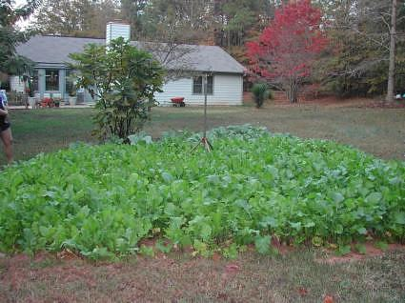

The Two Tine Weed Fork can also be used by professional landscaping and lawn maintenance companies, which can use this new device to improve their service and improve the working conditions of its employees.

SIC | Industry | Companies | Annual Sales
0782 | Lawn & Garden Services | 88,806 | $44.651 billion

The following chart shows the most recently recorded sales history of Lawn & Garden Service companies:
Source: The Lifestyle Market Analyst and U.S. Bureau of the Census

Annual sales of this industry grew an astounding 42.59 percent in this most recently recorded five-year period.

Cost & Price Estimates

For
The Two Tine Weed Fork

All estimates for the possible costs and prices of a new, yet-to-be-manufactured item are very difficult to estimate. This difficulty is due to potential variations in the costs of initial materials, the rate of production for the item, and its initial consumer demand. As a result, these estimates are very difficult to comprise.
Moreover, research on estimated costs and prices is very restricted so as to avoid improper disclosure of the Two Tine Weed Fork while still in these beginning stages.
In order to provide further detailed information for consideration, however, such estimates should be offered. The “Best Estimate” enclosed within is primarily based upon pricing of similar products (when possible) by this applicable manufacturing category, current cost of necessary materials, and average value added for the applicable manufacturing industry.
These estimates are subject to change and are enclosed only to offer a preliminary means of evaluation of product value for the Two Tine Weed Fork. Of course, only a manufacturer could properly determine the initial costs and prices.
The estimates on potential costs and prices for the Two Tine Weed Fork, throughout the line of distributors, could be:
 | Low Range | Mid Range | High Range
Materials Cost | $3.40 | $4.25 | $5.35
Manufacturer’s Cost | $5.38 | $6.78 | $8.41
Wholesale Price | $8.73 | $10.91 | $13.64
Supplier’s Price | $11.57 | $14.46 | $18.08
Retail Price (MSRP) | $16.50 | $20.65 | $25.79

REMINDER: It is extremely important to remember that the above costs and prices are only estimates. Actual costs and prices can only be determined by manufacturing companies with a good understanding of their own production capabilities and by suppliers and outlets, based on the final prices offered to them.

